Veteran Outreach Examples
1. Testimonial Post
See how NATROX® O₂ helped this U.S. Army Veteran heal his leg ulcers.
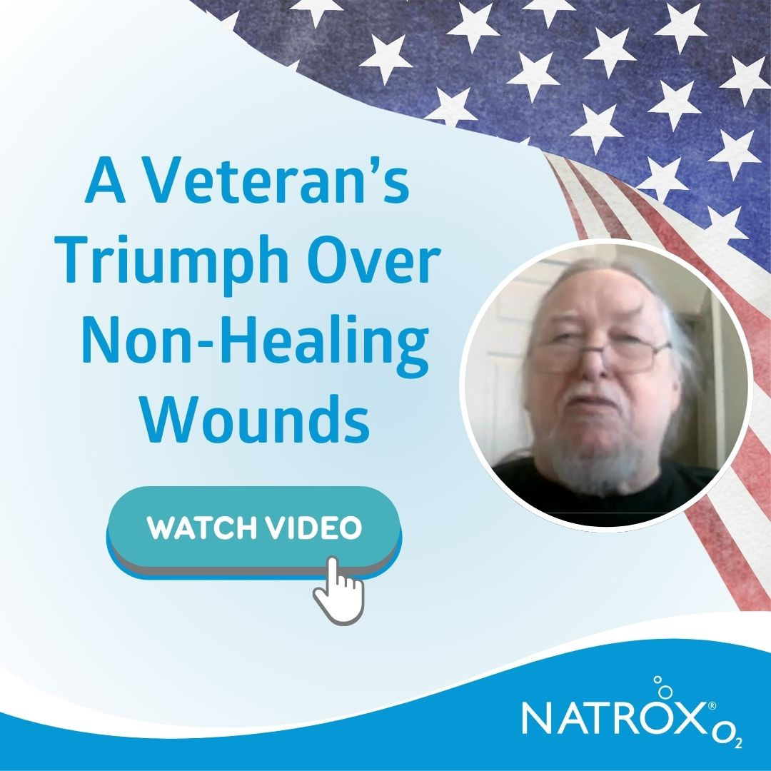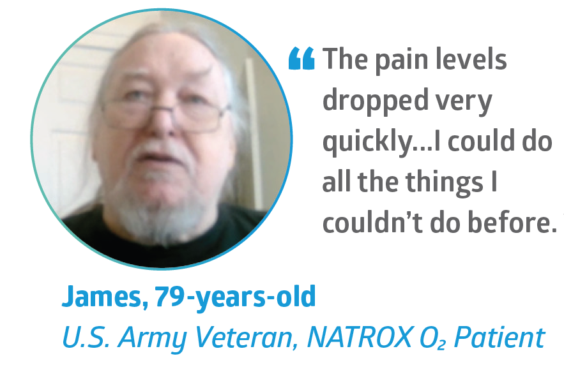
Website Link: https://www.natroxwoundcare.com/resource/a-veterans-triumph-over-non-healing-wounds/
Instagram Post to Reshare: https://www.instagram.com/reel/DZP7jbtnBdO/?utm_source=ig_web_copy_link&igsh=MzRlODBiNWFlZA==
Facebook Post to Reshare: https://www.facebook.com/share/v/1GVnnm7UJf/
2. General Awareness Post
Did you know?
Veterans with VA health benefits have access to Continuous Topical Oxygen Therapy (NATROX® O₂) for diabetic foot ulcers and other non-healing wounds.
Many Veterans can continue seeing their current wound care provider through VA Community Care while accessing this benefit.
If you or a Veteran you know has a wound that isn't healing, ask your care team:
"Can I try NATROX® O₂ to help my wound heal?"

3. Caregiver-Focused Post
Caring for a Veteran with a non-healing wound?
You may be able to help them access a benefit they've already earned.
Veterans with health benefits can access Continuous Topical Oxygen Therapy (NATROX® O₂), even if they're receiving care through a VA Community Care provider.
If your loved one's wound isn't healing as expected, ask their healthcare team whether this therapy may be appropriate.

4. Newsletter Blurb
Veteran Resource Spotlight
If you're a Veteran living with a diabetic foot ulcer or another non-healing wound, you have access to advanced therapies like NATROX® O₂ Continuous Topical Oxygen Therapy through VA health benefits.
Veterans can even continue receiving care from their trusted provider through VA Community Care while using this therapy.
Talk with your healthcare provider if you'd like help learning more about next steps.

5. Short Facebook or LinkedIn Post
Veterans: If you have a wound that isn't healing, you may have more treatment options than you realize.
If you have VA health benefits, NATROX® O₂ Continuous Topical Oxygen Therapy, can be ordered through your VA healthcare provider.
Ask about it today and get on the road to healing.

6. Event or Resource Fair Handout
Helping Veterans Access Their Benefits
If you know a Veteran living with a diabetic foot ulcer or another non-healing wound, share this information:
✔ NATROX® O₂ is available for Veterans with VA health benefits.
✔ Many Veterans can continue receiving care from their current provider through VA Community Care.
✔ Questions about eligibility or the process? Spartan Medical can help.
Ask your healthcare team whether NATROX® O₂ may be an option.

